# Abstract

The stock market, a key driver of the global economy, presents a formidable challenge for accurate prediction due to its intricate, chaotic, and dynamic nature. This study explores machine learning approaches, specifically comparing three prediction models—Long Short-Term Memory (LSTM), Random Forest, and Support Vector Machine (SVM). The analysis incorporates historical stock trading data, including open, high, low, and close prices, and technical analysis indicators such as moving average, Relative Strength Index (RSI), Moving Average Convergence Divergence (MACD), and Commodity Channel Index (CCI). The evaluation focuses on the performance of these models in predicting future trends in stock prices, utilizing data from the Nepal Stock market spanning from 2013 to 2023. The selected stocks for analysis include Nabil Bank Limited, NIC Asia Bank Limited, and NMB Bank Limited. Through rigorous assessment, it is determined that LSTM demonstrates superior overall performance compared to Random Forest and SVM. This research contributes valuable insights into the effectiveness of machine learning models in forecasting stock market trends, with implications for investors and financial practitioners.

# Introduction

Predicting stock market trends has captivated the interest of not just traders, but also computer engineers. Stock market predictions typically leverage two primary methods: historical data analysis and the examination of social media information. Historical data analysis involves scrutinizing previous stock-related metrics, including opening and closing prices, high and low prices, adjusted closing prices, and trading volume.

The realm of stock marketplace prediction is difficult, given the multitude of complex financial indicators and the volatile nature of the market. Nonetheless, advances in generation have created possibilities for greater reliable returns inside the stock marketplace. These technological improvements additionally empower specialists to identify the maximum precious signs for reinforcing predictive accuracy. Accurate market cost predictions are pivotal for maximizing the profitability of stock option investments whilst concurrently mitigating risks.

Recurrent Neural Networks (RNNs) are a powerful tool for managing sequential statistics. Among the numerous RNN architectures, Long Short-Term Memory (LSTM) stands proud as one of the maximum successful and powerful techniques

LSTM introduces a memory cell, a fundamental computational unit that supplants the traditional artificial neurons within the network's hidden layers. These memory cells equip networks with the capability to effectively associate past information, even when it's distant in time. This feature makes LSTMs exceptionally well-suited for dynamically comprehending data structures over time and achieving remarkable predictive accuracy.

The research paper presented here focuses on modeling and forecasting stock returns for a specific stock (stock name) using LSTM. The examination involved gathering a big dataset spanning several years (number of years) of historical data for the chosen stock ( stock name), which was used for training and validating the LSTM model.

# Machine Learning Model:

# Working of LSTM:

LSTM networks, which stand for Long Short-Term Memory networks were created as an improvement, over neural networks (RNNs) to tackle the issues of long-term dependency and vanishing gradient. They excel in processing data like time series, text and speech by utilizing valuable information from previous data points.

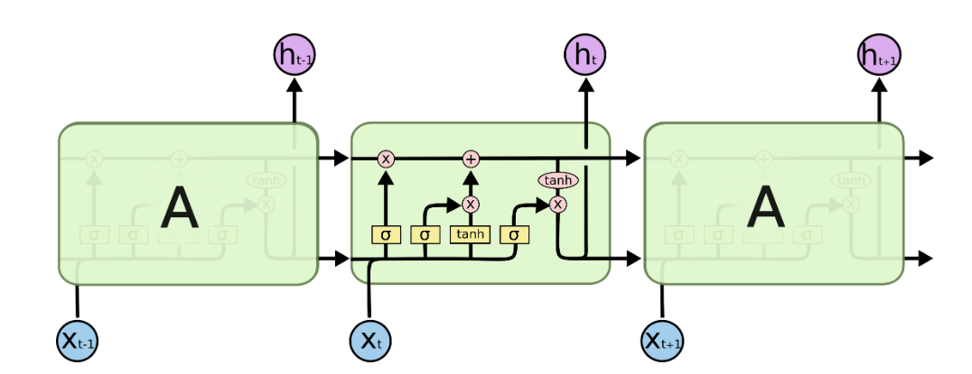

Figure: The internal structure of an LSTM […]

Cell State; The central component of an LSTM is the cell state, which acts as a conveyor belt spanning the entire sequence. Think of it as a long-term memory that holds information about the encountered data far.

Gates; LSTMs employ a set of gates to regulate the flow of information into and out of the cell state. These gates leverage sigmoid and tanh activation functions;

* Forget Gate; The forget gate takes into account both the cell state and the current input generating a number between 0 and 1 for each element in the cell state. A value, to 1 implies "retain this " while closer to 0 means "ignore this entirely." It determines which past information should be discarded.
* Input Gate; The input gate comprises two parts. To begin with there is a layer called the "input door layer" that determines which values, in the cell state should be modified. Following that there is another layer called the tanh layer which generates a vector of values that can be incorporated into the cell state. This specific component regulates what sort of information needs to be stored.
* Update Cell State: The input gate's output is used to update the cell state. It decides which parts of the candidate values should be added to the current cell state. This allows the model to learn which new information is important to remember.
* Output Gate: The output gate decides what will be the output of the LSTM cell. It is a combination of the current cell state and the filtered and freshest added data. The output can be sent to the next LSTM cell in the sequence or used for the final prediction in a sequence.

# ****Random Forest****

Random Forest is a popular machine learning algorithm that combines multiple decision trees to improve the accuracy and stability of the model. The working principle of Random Forest is based on the concept of ensemble learning, where multiple weak models are combined to create a strong model.

In Random Forest, multiple decision trees are trained on random subsets of the training data, and each tree is built with a different set of features. The final prediction is made by aggregating the predictions of all the trees. This approach helps to reduce the overfitting problem and improves the generalization of the model.

Random Forest also uses a technique called bagging (Bootstrap Aggregating) to reduce the variance of the model. Bagging involves training each tree on a random subset of the training data, which helps to reduce the correlation between the trees and improves the diversity of the model.

O**verall**, Random Forest is a powerful algorithm that combines the strengths of multiple decision trees to create a robust and accurate model. Its ability to handle high-dimensional data and to provide accurate predictions even with a small number of training examples make it a popular choice for many machines learning tasks.

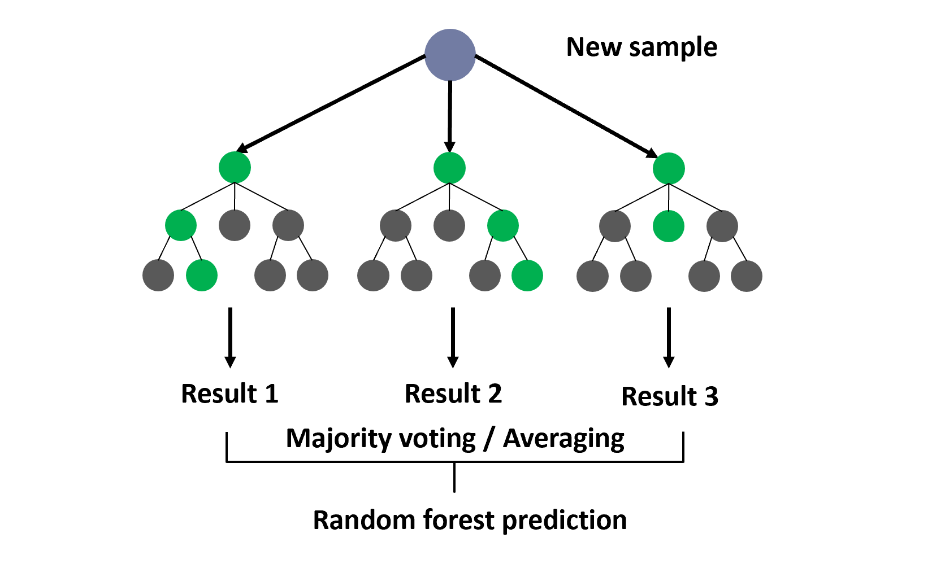

# SVM

Support Vector Machines (SVMs) are a type of supervised learning algorithm that can be used for classification and regression tasks. SVMs aim to find the optimal hyperplane that separates the data into different classes or predicts the output value for new inputs.

The working principle of

SVMs is based on the concept of finding the optimal hyperplane that maximizes the margin between the classes.

In other words, SVMs try to find the line, plane, or hyperplane that best separates the data into different classes.

The margin is the distance between the hyperplane and the nearest data points, and the goal is to maximize this margin as much as possible.

To achieve this, SVMs use **a kernel** function to transform the data into a higher-dimensional space, where it becomes easier to find the optimal hyperplane. The kernel function maps the original data into a higher-dimensional space by computing a dot product between the data points.

Once the data has been transformed, SVMs use a quadratic programming algorithm to find the optimal hyperplane that maximizes the margin. This hyperplane is then used to classify new inputs.

**In summary,** SVMs work by transforming the data into a higher-dimensional space using a kernel function, and then finding the optimal hyperplane that maximizes the margin between the classes using a quadratic programming algorithm.

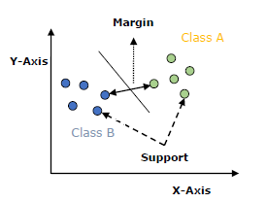

# **Literature Review**

Researchers have explored an array of machine learning techniques like Support vector machines (SVM), LSTM, and regression to ever-evolving Artificial Neural Networks (ANN).

ANN is one of the most widely used models reviewed by Mintarya et al. [1] and elaborated by [2] to present a diverse range of approaches [2]

Furthermore, several researchers have explored various methods employing ANN models. For instance, Bing et al. employed Back-Propagation Neural Networks (BPNN) to predict the Shanghai Stock Exchange Composite Index [3]. Wensheng et al. compared Nonlinear Independent Component Analysis (NLICA) and BPNN for the Asian stock market [4]. Bailings et al. used random forest (RF), AdaBoost, kernel factory, NN, SVM, and k-nearest neighbors (KNN) to predict the stock market’s direction for a year [5]. Patel et al. discussed several machine learning models, which are ANN, SVM, RF, and Naive Bayes [6][1], as well as made stock market index predictions using ANN, SVM, and RF [7][..3]. Olivera et al. used a modified ANN to predict market behavior and stock market trends [8][..18], and Li et al. compared Extreme Learning Machine (ELM) with SVM and BPN, the result was that kernelized ELM and SVM had higher precision than BPNN and normal ELM [9][..19].

In addition to artificial neural networks (ANN), the support vector machine (SVM) model finds widespread application in research endeavors. Ding et al. utilized SVM for forecasting stock market prices based on extensive public news data [10][..20]. Meanwhile, Hegazy et al. conducted a comparative analysis between the least-squares SVM (LS-SVM) algorithm and particle swarm optimization (PSO) in the context of the financial sector [11][..21]. Some researchers have also made modifications to the SVM model. For instance, Lin et al. assessed the performance of correlation-based SVM in comparison to quasi-linear SVM [12][.22], and Ren et al. investigated the accuracy of SVM when integrated with sentiment analysis [13][.23].

Aside from the two models above (ANN and SVM), another widely used model is LSTM. Selvin et al. discussed their approaches involving Long Short-Term Memory (LSTM), Recurrent Neural Network (RNN), and Convolutional Neural Network with a sliding window (CNN-sliding window) [14] [**6].** Chen et al. focused on the utilization of the LSTM model [15][..7]. Nelson et al. carried out a comparison between LSTM, Random Forest (RF), and Multilayer Perceptron (MLP) [16][.8]. Additionally, G. et al. explored methods involving MLP, RNN, LSTM, and CNN [9]. Moghar et al. used RNN-based LSTM [17] [.14]; Roondiwala et al. made a model using LSTM and RNN [18][.15]; Kang et al. used a generative adversarial networks (GAN) model combined with MLP and LSTM [16]; Akita et al. used the LSTM approach with paragraph vector [19] [.17]; Parmar et al. used Regression and LSTM on Indian stock exchange [20][.09], and Murtaza et al. used LSTM on nifty 50, Indian Stock Market index.[XXX]

Several alternative models, including regression, can be employed for stock market prediction. Sharma et al. have explored various regression models in their work [21][,24]. Furthermore, the utilization of support vector regression (SVR) optimized with a chaos-based firefly algorithm is examined by Kazem et al. [22][.25]. Another approach involves employing the K-nearest neighbors (KNN) model for stock market forecasting, as demonstrated by Alkhatib et al., who applied the KNN algorithm and a non-linear regression approach to predict stock prices for six prominent companies listed on the Jordanian stock exchange [23][.26]. Another approach using a random forest classifier and backtracking demonstrate by Bhamidipati et al. [29_] [24]

Results and Discussion

Technical Analysis

# Datasets and Parameters and library used

Dataset taking from the commercial bank.

The dataset I take is form

Source [shareshansar.com and nepsealpha.com][link](dfgdfgdfg)

And the ten technical parameters:

1. Simple Moving Average
2. Weighted Moving Average
3. Momentum
4. Stochastic %K
5. Stochastic %D
6. Relative Strength Index (RSI)
7. Moving Average Convergence Divergence (MACD)
8. Larry William R%
9. A/D (Accumulation/Distribution) Oscillator
10. Commodity Channel Index

Simple Moving Average (SMA): It is a calculation that averages the prices of a security over a specified period, providing a smoothed trend line to identify the overall direction of the price movement.

Weighted Moving Average (WMA): Similar to SMA, but it assigns different weights to different data points, giving more significance to recent prices.

Momentum: It measures the rate of change of a security's price and is used to identify the strength or weakness of a trend.

Stochastic %K: A momentum indicator that compares the closing price of a security to its price range over a specific period, indicating the position of the current close relative to the high-low range.

Stochastic %D: A smoothed version of the %K, providing a signal line to help identify potential buy or sell signals.

Relative Strength Index (RSI): Measures the magnitude of recent price changes to evaluate overbought or oversold conditions, indicating potential reversal points.

Moving Average Convergence Divergence (MACD): A trend-following momentum indicator that shows the relationship between two moving averages of a security's price.

Larry Williams R%: Also known as Williams Percent Range, it measures the level of the closing price relative to the high-low range over a specific period, helping identify overbought or oversold conditions.

Accumulation/Distribution (A/D) Oscillator: It calculates the accumulation or distribution of a security by analyzing volume and price data, providing insights into buying or selling pressure.

Commodity Channel Index (CCI): A momentum oscillator that measures the current price level relative to its average price, helping identify overbought or oversold conditions and potential trend reversals.

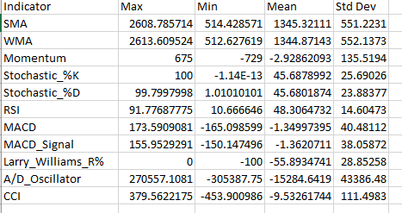

# Methodology

# Result and Discussion

# Bibliography

|  |  |
| --- | --- |
| [1] | J. N. H. A. S. A. A. K. Latrisha N. Mintaryaa, "Machine learning approaches in stock market prediction: A systematic literature review," in *International Conference on Computer Science and Computational Intelligence*, 2023. |
| [2] | R. A. ,. P. A. Chin Kim On, "A review of stock market prediction with Artificial neural network (ANN)," in *IEEE International Conference on Control System, Computing and Engineering,*, 2013. |
| [3] | H. J. Z. S. Bing Yang, "Stock Market Prediction Using Artificial Neural Networks," in *Trans Tech Publications Ltd*, Switzerland, 2012. |
| [4] | J.-Y. W. C.-J. L. Wensheng Dai, "Combining nonlinear independent component analysis and neural network for," *Expert Systems with Applications,* 2012. |
| [5] | D. V. d. P. N. H. R. G. Michel Ballings, "Evaluating multiple classifiers for stock price direction prediction," *Expert Systems with Applications,* 2015. |
| [6] | S. S. P. T. K. K. Jigar Patel, "Predicting stock and stock price index movement using Trend," *Expert Systems with Applications,* 2014. |
| [7] | S. S. P. T. K. K. Jigar Patel, "Predicting stock market index using fusion of machine learning," *Expert Systems with Applications,* 31 October 2014. |
| [8] | C. N. N. L. E. Z. Fagner A. de Oliveira, "Applying Artificial Neural Networks to prediction of stock price and improvement of the directional prediction index – Case study of PETR4, Petrobras, Brazil," *Expert Systems with Applications,* 2013. |
| [9] | H. X. ,. R. W. ,. C. ,. C. ,. F. W. ,. M. ,. D. Xiaodong Li, "Empirical analysis: stock market prediction via extreme learning," *Extreme Learning Machine and Application,* 2014. |
| [10] | Y. Z. T. L. J. D. Xiao Ding, "Using Structured Events to Predict Stock Price Movement:," *Conference on Empirical Methods in Natural Language Processing (EMNLP),* p. 1415–1425, 2014. |
| [11] | O. S. S. a. M. A. S. Osman Hegazy, "A Machine Learning Model for Stock Market," *International Journal of Computer Science and Telecommunications,* vol. 4, no. 12, 2013. |
| [12] | H. G. a. J. H. Yuling LIN, "An SVM-based Approach for Stock Market Trend Prediction," in *International Joint Conference on Neural Networks (IJCNN)*, 2013. |
| [13] | M. D. D. W. a. T. L. Rui Ren, "Forecasting Stock Market Movement Direction Using," *IEEE SYSTEMS JOURNAL,* vol. 13, no. 1, 2019. |
| [14] | V. R. E. G. V. K. M. Sreelekshmy Selvin, "Stock prediction using LSTM, RNN and CNN-sliding window model," in *International Conference on Advances in Computing, Communications and Informatics (ICACCI)*, 2017. |
| [15] | A. L.-b. m. f. s. r. p. :. A. c. s. o. C. s. market, "A LSTM-based method for stock returns prediction :," in *2015 IEEE International Conference on Big Data (Big Data)*, Santa Clara, CA, USA, 2015. |
| [16] | A. C. M. P. R. A. d. O. David M. Q. Nelson, "Stock Market’s Price Movement Prediction With LSTM Neural Networks," in *2017 International Joint Conference on Neural Networks (IJCNN)*, Anchorage, AK, USA, 2017. |
| [17] | M. H. Adil MOGHAR, "Stock Market Prediction Using LSTM Recurrent Neural Network," *Procedia Computer Science,* vol. 170, pp. 1168-1173, 2020. |
| [18] | H. P. S. V. Murtaza Roondiwala, "Predicting Stock Prices Using LSTM," *International Journal of Science and Research (IJSR),* vol. 6, no. 4, 2017. |
| [19] | A. Y. T. M. K. U. Ryo Akita, "Deep Learning for Stock Prediction Using Numerical and Textual Information," in *2016 IEEE/ACIS 15th International Conference on Computer and Information Science (ICIS)*, 2016. |
| [20] | G. E. V. K. M. S. K. Hiransha M, "NSE Stock Market Prediction Using Deep-Learning Models," *Procedia Computer Science,* vol. 132, pp. 1351-1362, 2018. |
| [21] | A. Sharma, D. Bhuriya and U. Singh, "Survey of stock market prediction using machine learning approach," in *2017 International conference of Electronics, Communication and Aerospace Technology (ICECA)*, Coimbatore, India, 2017. |
| [22] | E. S. F. K. H. M. S. Ahmad Kazema, "Support vector regression with chaos-based firefly algorithm for stock market," *Applied Soft Computing,* vol. 13, no. 2, pp. 947-958, 2013. |
| [23] | N. H. I. H. M. K. A. S. Khalid Alkhatib, "Stock Price Prediction Using K-Nearest Neighbor (kNN) Algorithm," *International Journal of Business, Humanities and Technology ,* vol. 3, 2013. |
| [24] | S. D. Venkata Sai P Bhamidipati, "Stock Price Prediction using Random Forest Classifier and Backtesting," in *2023 International Conference on Computer Communication and Informatics (ICCCI)*, 2023. |